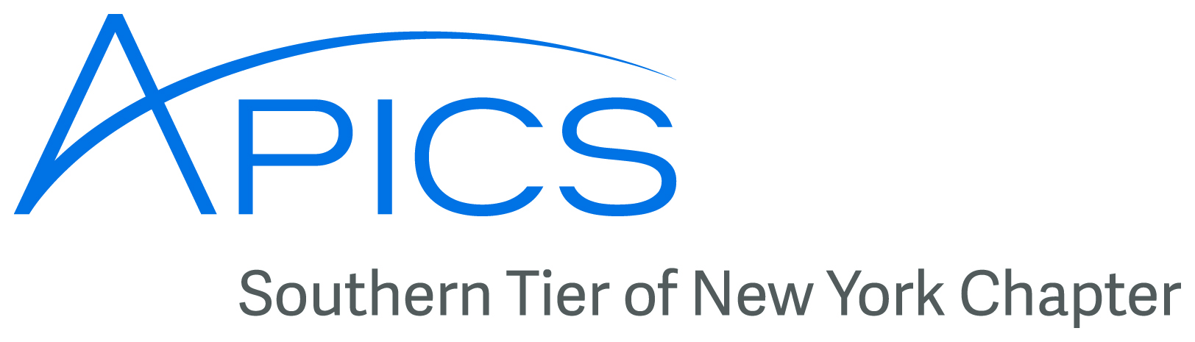
January 2016
www.stapics.org


Upcoming Events
Join the Southern Tier Chapter of APICS as we tour ...
The Floyd L. Maines Veterans Memorial Arena
STAPICS will get a behind the scenes tour of how the Arena works! Ever wonder about the ice the Senators skate on, and where it goes when not in use? How they get the stages in and set up for Disney on Ice? How do they know how much popcorn to make for an event! Let’s find out!!

Wednesday Feb 3 at 6PM
RSVP to steve.stanchak@ricoh-usa.com by Feb 2nd
The Floyd L. Maines Veterans Memorial Arena is a 5,000-seat arena (with up to 7,000 person capacity depending on configuration). It is home to the Binghamton Senators (American Hockey League), minor-league affiliate of the Ottawa Senators (NHL). The Arena anchors the downtown area as a center for a wide variety of sports, concerts, expos, and family events.

The Arena was built in 1973 as a result of a nationwide design competition. Some of the top stars in the world have played the Arena at one time or another. The first act at the Arena was the Barnum & Bailey circus in May 1973. Chicago played the first concert at the Arena (with Bruce Springsteen as opener) on June 20, 1973. The first regular tenants of the Arena were the Broome Dusters (NAHL, 1973-1977), followed by the Binghamton Dusters (AHL, 1977-1980), the Binghamton Whalers (AHL, 1980-1990), the Binghamton Rangers (AHL, 1990-1997), and the B.C. Icemen (UHL, 1997-2002).

Today, the Arena is home to the Binghamton Senators (AHL, 2002-present), and it continues to provide a constant stream of top-class events to the Greater Binghamton area.


Come Learn from the Toastmasters!
Join APICS and PMI on Thursday, January 21st
Are you interested in improving your communication, public speaking, and leadership skills? You have a great opportunity to kick them up a notch at our January chapter meeting on "The World of Toastmasters" with the River City Toastmasters Club of Binghamton, NY. All chapter meetings are open to the public.

Upcoming Events (continued)

Date: Thursday, January 21, 2016

Time: 6 - 8 p.m.
- 6 to 7: Dinner & Networking.
- 7 to 8: Presentation

Place: Brothers 2, 2901 Watson Blvd, Endwell, NY

PDUs: 1 PDU in the Leadership Category of the new Talent Triangle (included in cost)

Menu: Salad, Entrée (TBD), Beverage, Dessert, Cash Bar

Cost:
- PMI Binghamton Chapter members and APICS members - Dinner/Meeting: $20, Meeting only: $10
- Students - Dinner/Meeting: $10, Meeting only: $5
- All Others - Dinner/Meeting: $25, Meeting only: $10

Register at http://www.pmi-binghamton.org/index.php/events/registration and select “January Annual Meeting”.

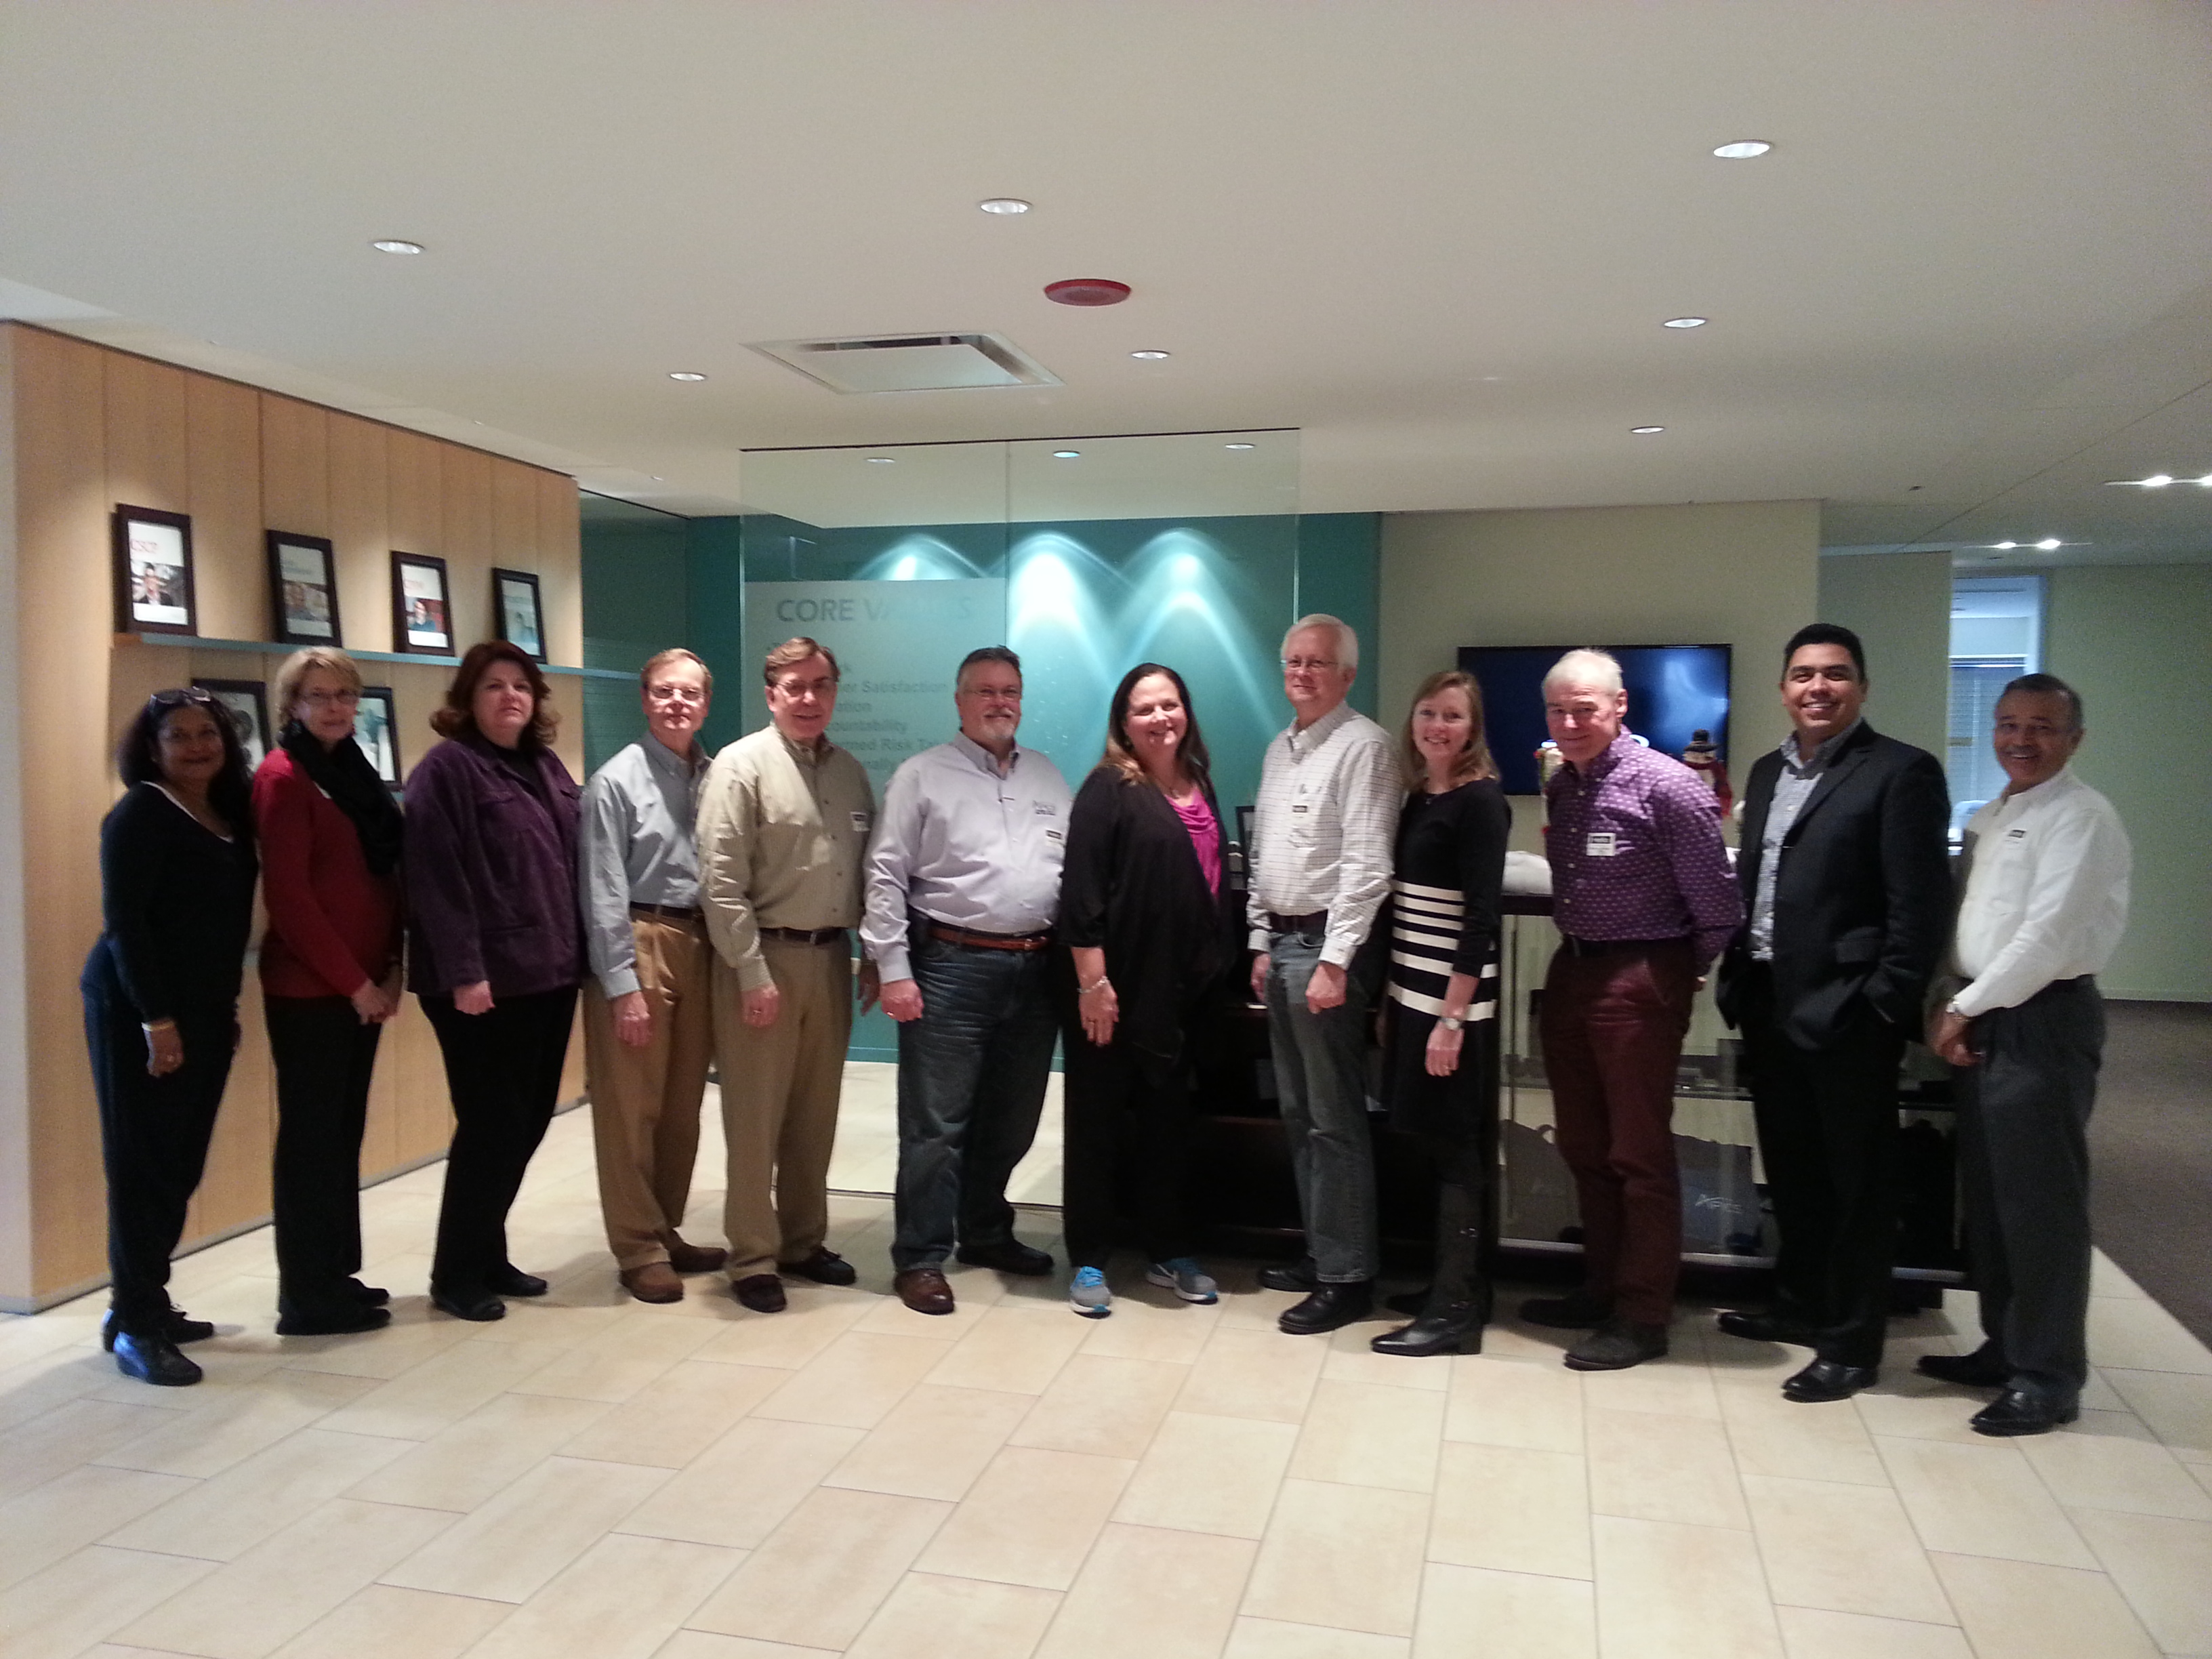
STAPICS News from You

Don Sheldon represented the Southern Tier APICS chapter at the APICS headquarters in Chicago while working on a corporate project in December.

Don will also be taking three teams of students from Binghamton University to the APICS Northeastern District 7th annual student case competition on March 4th and 5th in Albany, NY.
The Southern Tier APICS chapter is pleased to sponsor teams from our student chapter for the third year in a row. In previous years our teams have won 1st and 2nd place in 2014, and 3rd place in 2015.

Featured Employee of the Month
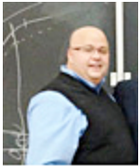
Steve Whited, Senior Manager of Forecasting and Inventory Management, Sidney, N.Y.
Steve Whited has more than 30 years of practical experience in forecasting and inventory management, beginning with 13 years as a manufacturing supervisor and manager at International Paper and then in various roles at the ACC O Brands Sidney facility for over 17 years. Steve generously shares his professional expertise with college students – it’s his way of passing on his knowledge to the forecasting and inventory control profession. His twice -a-year visits to classes in the Binghamton University Business Operations Management program enthusiastically captivate the students’ interest and, in so doing, invigorate his own commitment to his job.
Featured Employee of the Month (continued)
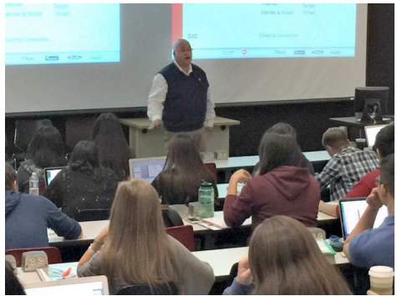
The students energize me,” Steve says. “Their questions are astute, and they are very engaged, asking plenty of questions. They make it easy.” He gets their attention right from the start of his presentation, with his first slide showing their potential earnings if they graduate and go into forecasting/inventory management. He also shares stories from the field, and answers one of his most common questions, “Why don’t companies order their own products from China,” by explaining the concept of manufacturability .
Steve has been speaking to the Business Operations Management classes for five years. He provides insight into the module on CPFR (collaboration, planning, forecasting, replenishment) speaking to about 350 students each time he visits. Steve’s experience in the inventory control field gives him his expertise for the class. His roles in Sidney include analyst, assistant supervisor, assistant manager and now senior manager of forecasting and inventory management. He is vice -president of the local APICS chapter (American Production and Inventory Control), and his 20-year involvement with that group gives him a broad knowledge of distribution and warehousing to share with students. Steve has seen many changes through the years with the Sidney operation, including system and organizational changes, mergers, and more closely monitored inventory levels and OSMI (Obsolete and Slow Moving Inventory ) reporting.
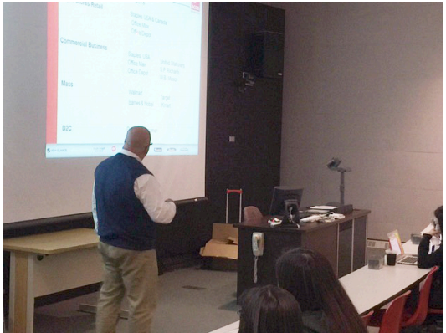
“It’s an exciting, growing time,” Steve says. “Now we have added School and Office Products to inventory we manage. I enjoy being part of a team that works so well with customers and our internal colleagues.” Steve brings ACCO Brands connections to Binghamton University in other ways, as well, through his involvement with campus events. At a recent campus job fair, Sidney HR representatives were asked where Steve was. His connections to the students are highly valued by both the Sidney HR team and the college’s Business Operations Management program.

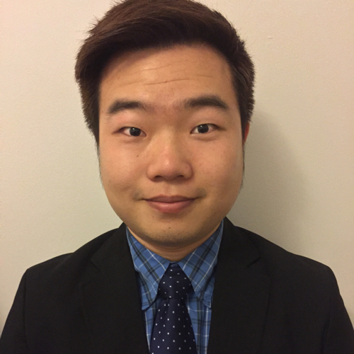
Introducing New Student Chapter Liaison
Former Liaison Kara Youngs will be spending her spring semester working as an Industrial Engineering intern at Disney World in Orlando, FL. The BU APICS student chapter has elected Shi Ting (Westin) Zing as the new Liaison. Westin is currently a senior studying Management with a concentration in Supply Chain. He is a founding member of the student chapter and was previously responsible for outreach and public affairs.
Westin Zeng: szeng2@binghamton.edu
School of Management' 16
Supply Chain Management & Quantitative Finance

Binghamton University - State University of New York (SUNY)


Have News, Events, or Items of Interest?
To have it included in next month’s newsletter
email it to jedestrada.writer@gmail.com by next
month’s B.O.D. meeting on February 10th.

___________________________________________________________________
Board of Directors 2016
President  Dave Gardner, CPIM  dgardner@emtmetals.com  Secretary  Debbie Unkel, CPIM  deb.unkel@raymondcorp.com  Director of Marketing & Publicity  Stephanie Ray  Sray02207@gmail.com  Director of Programming  Steve Stanchak, CPIM  sstanchak@stny.rr.com  Student Chapter Liaison  Westin Zeng  szeng2@binghamton.edu | Executive VP /Director of Finance  Steve Whited  steven.whited@acco.com  Director of Membership/Director of Chapter Standards/Director of Online Publication  Lee Schechter , CPIM  lschechter@stny.rr.com  Director of Education/2nd Director of  Student Relations  Don Sheldon, CFPIM CIRM CSCP  dsheldon@sheldoninc.com  Director of Communications  Jed Estrada  jedestrada.writer@gmail.com
Southern Tier APICS
PO Box 1107
Binghamton NY 13902-1107

